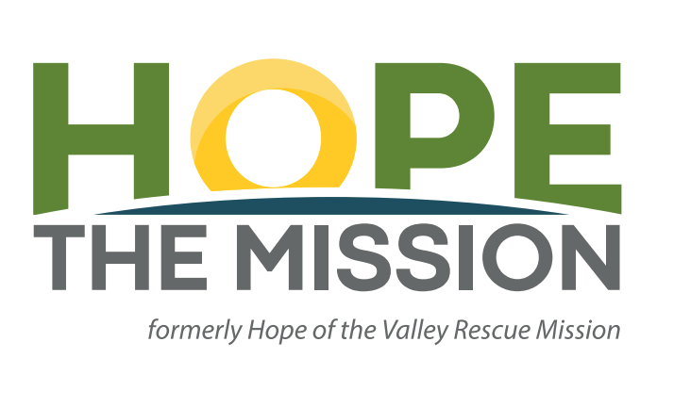
Volunteer
Waiver and Release
Form

Volunteer Name: ______________________________________________________________
- Check here if Volunteer is under age 18
Contact Email (required): _______________________________________________________
Parent or Legal Guardian Email (required if Volunteer is under age 18): ___________________
Address: _____________________________________________________________________
Phone: ______________________________________________________________________
Emergency Contact
Name: ______________________________________________________________________
Relationship to Participant: _______________________________________________________
Phone Number: _______________________________________________________________
- Check here to receive the Hope the Mission Newsletter.

VOLUNTEERS MUST COMPLETE THE
WAIVER AND RELEASE FORM

PARENT/LEGAL GUARDIAN SIGNATURE IS REQUIRED
IF VOLUNTEER IS UNDER AGE 18

Hope The Mission
PO Box 7609 Mission Hills, CA 91346
info@hopeofthevalley.org
Phone: (818) 392-0020

WAIVER AND RELEASE FORM RELEASE OF LIABILITY

In return for being allowed to participate in Hope the Mission volunteer activities and all related
activities, including any activities incidental to such participation (“Volunteer Activities”), the undersigned Volunteer or Parent/Legal Guardian of Volunteer if Volunteer is under age 18 (hereafter referred to using “I”, “me”, or “my”) releases and agrees not to sue Hope the Mission or its officers, directors, employees, sub-contractors, sponsors, agents, and affiliates from all.
present and future claims that may be made by me, my family, estate, heirs, or assigns for property damage, personal injury, or wrongful death arising because of my participation in the Volunteer Activities Wherever, whenever, or however the same may occur.

I understand and agree that the Mission is not responsible for any injury or property damage arising out of the Volunteer Activities, even if caused by their ordinary negligence or otherwise.

I understand that participation in the Volunteer Activities involves certain risks, including, but not limited to, serious injury and death. I am voluntarily participating in the Volunteer Activities with knowledge of the danger involved and I agree to accept all risks of participation.

I also agree to indemnify and hold harmless the Mission for all claims arising out of my participation in the Volunteer Activities.

I understand that this document is intended to be as broad and inclusive as permitted by the laws of the state in which the Volunteer Activities take place and agree that if any portion of this Agreement is invalid, the remainder will continue in full legal force and effect.

I also acknowledge that the Mission have not arranged and do not carry any insurance of any kind for my benefit or that of Volunteer (if Volunteer is under 18), my parents, guardians, trustees, heirs, executors, administrators, successors and assigns. I represent that, to my knowledge, I am in good health and suffer no physical impairment that would or should prevent my participation in Volunteer Activities.

If I am currently an employee of Hope the Mission, I acknowledge that I am voluntarily committing to participate in volunteer activities and I will not be receiving any compensation for my time.

I also understand that this document is a contract which grants certain rights to and eliminates the liability of the Hope the Mission.

____________________________________________________________________________
(Signature of Volunteer) Date
I am of legal age and am freely signing this agreement. I have read this form and understand that by signing this form, I am giving up legal rights and remedies.

____________________________________________________________________________
(Signature of Parent/Legal Guardian if Volunteer is Under 18) Date
I am the parent or legal guardian of the Volunteer. I am of legal age and am freely signing this agreement. I have read this form and understand that by signing this form, I am giving up legal rights and remedies.

PUBLICITY RELEASE
In return for being allowed to participate in Hope the Mission volunteer activities and all
related activities, including any activities incidental to such participation (“Volunteer Activities”), the undersigned Volunteer or Parent/Legal Guardian of Volunteer if Volunteer is under
age 18 (hereafter referred to using “I”, “me”, or “my”) hereby grants to the Mission, and each
of its subsidiaries, affiliates, agents, advertising or promotional agencies, and partners, and all
such entities’ officers, directors, agents, employees, respective successors and assigns (collectively, “Authorized Parties”), the absolute and irrevocable right and permission to use, publish, broadcast and/or copyright the use of Volunteer’s name, address, voice, photograph and/or likeness, caricature, and personal information, in its current form or as retouched, digitized, cropped, altered, distorted or modified in any way, in any and all advertising, promotional, or other materials based upon or derived from the Volunteer Activities in any manner, in any media whatsoever for any and all purposes, including by way of example but without limitation advertising, promoting or publicizing products and services throughout the universe, in perpetuity, in any and all media now known or hereafter devised (including without limitation on the Internet), without additional compensation. I further agree that anything derived therefrom will be owned solely by the Authorized Parties. I shall not authorize the use of any print, negative or other copy thereof by anyone other than the Authorized Parties.

I understand that this document is intended to be as broad and inclusive as permitted by the laws of the state in which the Volunteer Activities take place and agree that if any portion of this
Agreement is invalid, the remainder will continue in full legal force and effect.

____________________________________________________________________________
(Signature of Volunteer) Date

I am of legal age and am freely signing this agreement. I have read this form and understand that by signing this form, I am giving up legal rights and remedies.

____________________________________________________________________________
(Signature of Parent/Legal Guardian if Volunteer is Under 18) Date

I am the parent or legal guardian of the Volunteer. I am of legal age and am freely signing this
agreement. I have read this form and understand that by signing this form, I am giving up legal
rights and remedies.

